**AN ENHANCED DATA SHARING USING TWO FACTOR PROTECTION MECHANISM IN CLOUD STORAGE**

**A PROJECT REPORT**

***Submitted by***

**M.ABINAYA (810015104002)**

**K.PRAGANYA (810015104062) *in partial fulfillment for the award of the degree***

***of***

**BACHELOR OF ENGINEERING**

**in**

**COMPUTER SCIENCE AND ENGINEERING**



**UNIVERSITY COLLEGE OF ENGINEERING**

**BIT CAMPUS,TIRUCHIRAPALLI**

**ANNA UNIVERSITY:: CHENNAI 600 025**

**APRIL 2019**

**UNIVERSITY COLLEGE OF ENGINEERING,**

**BIT CAMPUS,**

**TIRUCHIRAPALLI-620 024**

**BONAFIDE CERTIFICATE**

Certified that this project report entitled, **“AN ENHANCED DATA SHARING USING TWO FACTOR PROTECTION MECHANISM IN CLOUD STORAGE”** is the bonafide work of ''ABINAYA M (810015104002) and PRAGANYA K (810015104062) who carried out the project work under my supervision

**SIGNATURE SIGNATURE**

**Dr.D.VENKATESAN Mr.C. SURESHKUMAR**

**HEAD OF THE DEPARTMENT SUPERVISOR**

Department of CSE& IT Department of Information technology

University College of Engineering University college of engineering

Anna university-BIT Campus Anna university-BIT Campus

Tirchirapalli-620 024 Tiruchirapalli-620 024

**Submitted for the University viva voce Examination held on …………...**

**INTERNAL EXAMINER EXTERNAL EXAMINER**

**DECLARATION**

We hereby declare that the work entitled "**AN ENHANCED DATA SHARING USING TWO FACTOR PROTECTION MECHANISM IN CLOUD STORAGE"** is submitted in partial fulfillment of the required for the award of the degree in B.E , in University College of Engineering , BIT Campus , Anna University , Tiruchirapalli . It is the record of our own work carried out during the academic year 2017 - 2018 under the supervision and guidance of **Mr .C. SURESH KUMAR,** Teaching fellow, Department of Information Technology, University College of Engineering ,BIT Campus, Anna University, Tiruchirapalli. The extend and source of information are derived from the existing literature and have been indicated through the dissertation at the appropriate places.

ABINAYA M

(810015104002)

PRAGANYA K

(810015104062)

I certify that the declaration made above by the candidates is true

Signature of the Guide,

Mr.C.SURESH KUMAR,

Teaching Fellow,

Department of Information Technology,

University College of Engineering,

Anna University-BIT Campus,

Tiruchirapalli- 620 024

**ACKNOWLEDGEMENT**

We would like to thank our honorable Dean **Dr.T.SENTHILKUMAR ,**Professor for having provided us with all required facilities to complete our project without hurdles.

We would like to express our sincere thanks to **Dr.D.VENKATESAN,** Head of the Department of CSE/IT , for his valuable guidence, suggestions and constant encouragement paved way for the successful completion of this project work.

We would like to thank our project coordinator**Mr.P.KARTHIKEYAN ,**[**Mr.C.RAMASAMY@SANKARRAM**](mailto:Mr.C.RAMASAMY@SANKARRAM)**,** Assistant ProfessorDepartment of Computer science and engineering for her kind support.

We would like to thank and express our deep sense of gratitude to our project guide **Mr.C.SURESH KUMAR,** Teaching Fellow, Department of Information Technology, for his valuable guidance throughout the project. We also extend our thanks to all other teaching and non teaching staff or their encouragement and support.

We thank our beloved parents and friends for their full support in the moral development of this project.

**ABSTRACT**

Two factor protection mechanism provide data security for cloud storage system. In cloud storage server the sender send an encrypted message to a receiver. The receives information need not be shown to the sender except the identity of the receiver. In order to decrypt the ciphertext the receiver need to passes two things. The first thing is secret key stored in a computer. The second thing is a security device connects to the computer. Ciphertext cannot be decrypted without either piece. When the security device is lost or stolen the cipher text cannot be decrypted. In cloud server it is done by alogorithm which execute immediately to change the ciphertext to be undecrypted by the device .The sender can completely know about the process. The cloud server cannot decrypt any ciphertext for anymore. Our system is not only secure but also practical.

**TABLE OF CONTENTS**

**CHAPTER NO TITLE PAGE NO**

**ABSRACT V**

**LIST OF FIGURES Viii**

**ABBREVATIONS ix**

1. **INTRODUCTION**
   1. Cloud Computing 1

1.2 Literature Survey 3

**2 SYSTEM REQUIREMENTS**

2.1 Hardware System Configuration 9

2.2 Software System Configuration 9

2.3 Software Environment 9

**3 DESCRIPTION OF THE PROJECT**

3.1 Problem Definition 12

3.2 Proposed System 12

**4 DESIGN OF THE SYSTEM**

4.1 Architectural Design 14

4.2 UML Diagrams 15

**5 SYSTEM IMPLEMENTATION AND TESTING**

5.1.Module 22

5.1.1Register 22

5.1.2 Login\Logout 22

5.1.3 File uploading 23

5.1.4 Key Management 23

5.1.5 Data Sharing 23

5.1.6 Data Viewing 23

5.2 Homomorphic Encryption 23

5.3 Types of Tests 24

**6 SCREEN SHOTS** 30

**7 CONCLUSION** 36

7.1 Appendix and Sampling coding 37

7.2 References 55

**LIST OF FIGURES**

**FIGURE NO TITLE OF FIGURE PAGE NO**

**4.1 ARCHITECTURAL DESIGN 20**

**4.2 UML DIAGRAMS**

4.2.1 Use case Diagram 22

4.2.2 Class Diagram 23

4.2.3Sequence Diagram 24

4.2.4 Deployment Diagram 25

**4.3 DATAFLOW DIAGRAM 27**

**LIST OF ABBREVATIONS**

**AWS --** Amazon Web Service

**NC** -- Network coding

**IBE –** Identity Based Encryption

**RAM –** Random Access Memory

**VM --** Virtual Machine

**API --** Application Programming Interface

**DFD --** Data Flow Diagram

**Pk** -- Public Key

**CHAPTER -1**

**INTRODUCTION**

**1.1CLOUD COMPUTING**

**Cloud computing** makes computer system resources, especially storage and computing power, available on demand without direct active management by the user. The term is generally used to describe data centers available to many users over the Internet.

Clouds may be limited to a single organization (enterprise clouds,) be available to many organizations (public cloud,) or a combination of both (hybrid cloud.) The largest public cloud is Amazon AWS.

Advocates of public and hybrid clouds note that cloud computing allows companies to avoid or minimize up-front IT infrastructure costs. Cloud providers typically use a "pay-as-you-go" model, which can lead to unexpected operating expenses if administrators are not familiarized with cloud-pricing models.

### **Private cloud**

Private cloud is cloud infrastructure operated solely for a single organization, whether managed internally or by a third party, and hosted either internally or externally.  private cloud project requires significant engagement to virtualize the business environment, and requires the organization to reevaluate decisions about existing resources. They have a significant physical footprint, requiring allocations of space, hardware, and environmental controls.

### **Public cloud**

A cloud is called a "public cloud" when the services are rendered over a network that is open for public use. Public cloud services may be free.

Technically there may be little or no difference between public and private cloud architecture, however, security consideration may be substantially different for services (applications, storage, and other resources) that are made available by a service provider for a public audience and when communication is effected over a non-trusted network. Generally, public cloud service providers like Amazon Web Services (AWS), Oracle, Microsoft.

**Hybrid cloud**

Hybrid cloud is a composition of two or more clouds (private, community or public) that remain distinct entities but are bound together, offering the benefits of multiple deployment models. Hybrid cloud can also mean the ability to connect collocation, managed and/or dedicated services with cloud resources. It allows one to extend either the capacity or the capability of a cloud service, by aggregation,integration or customization with another cloud service.

**1.2 LITERATURE REVIEW**

**[1]NC Cloud: A Network-Coding-Based Storage System in a Cloud-of-Clouds** NC Cloud is built on top of a network-coding-based storage scheme called the functional minimum-storage regenerating (FMSR) codes, which maintain the same fault tolerance and data redundancy as in traditional erasure codes (e.g., RAID-6), but use less repair traffic and, hence, incur less monetary cost due to data transfer. We implement a proof-of-concept prototype of NCCloud and deploy it atop both local and commercial clouds. We validate that FMSR codes provide significant monetary cost savings in repair over RAID-6 codes, while having comparable response time performance in normal cloud storage operations such as upload/download.

ADVANTAGES:

* It provides increased reliability as it stores an extra parity block.
* Increased read performance.

DISADVANTAGES:

* Lower performance with servers performing large amounts of write operations because of parity overhead.

**[2]Key-Aggregate Cryptosystem for Scalable Data Sharing in Cloud Storage** provides Data sharing is an important functionality in cloud storage. In this article, we show how to securely, efﬁciently, and ﬂexibly share data with others in cloud storage. The novelty is that one can aggregate any set of secret keys and make them as compact as a single key, but encompassing the power of all the keys being aggregated. We also describe other application of our schemes. In particular, our schemes give the ﬁrst public-key patient-controlled encryption for ﬂexible hierarchy, which was yet to be known.

ADVANTAGES:

* Decryption key should be send through a secure channel.
* It is effective public key encryption method.

DISADVANTAGES:

* It is not effective.
* Data transfer will not secure.

**[3]Distributed, concurrent, and independent access to encrypted cloud** We Propose a novel architecture that integrates cloud database services with data conﬁdentiality and the possibility of executing concurrent operations on encrypted data. The proposed architecture has the further advantage of eliminating intermediate proxies that limit the elasticity, availability and scalability properties that are intrinsic in cloud-based solutions. The efficiency of the proposed architecture is evaluated through theoretical analyses and extensive experimental results based on a prototype implementation subject to the TPC-C standard benchmark for different numbers of clients and network latencies.

ADVANTAGES:

* There are no theoretical and practical limits to extend our solution to other platforms and to include new encryption algorithm.
* It provides the same availability, elasticity, and scalability of the original cloud DBaaS because it does not require any intermediate server.

DISADVANTAGES:

* Cannot apply fully homomorphic encryption schemes because of their excessive computational complexity.

**[4]Security as a Service Model for Cloud Environment**

Provides a Cloud computing is becoming increasingly important for provision of services and storage of data in the Internet. The paper describes the design of the security architecture and discusses how different types of attacks are counteracted by the proposed architecture. We have implemented the security architecture and the paper discusses analysis and performance evaluation results.

ADVANTAGES:

* Rapid development of service.
* Easier support for mobile and remote users.

DISADVANTAGES:

* Some of the threads hits the network.

[5]**Towards a Secure Certiﬁcateless Proxy Re-Encryption Scheme**

Provides a Proxy re-encryption (PRE) is an attractive paradigm, which gives good solutions to the problem of delegation of decryption rights. In proxy re-encryption, a semi-trusted proxy translates a ciphertext for Alice into a ciphertext of the same plaintext for Bob, without learning any information of the underlying message. In order to solve these practical problems, we aim at constructing certiﬁcateless proxy re-encryption (CL-PRE) schemes.

ADVANTAGE:

* Which has been encrypted for one party, so that it may be decrypted by another.

DISADVANTAGE:

* Proxy Re-Encryption is generally not support for multi-party.

**CHAPTER-2**

**2.1HARDWARE SYSTEM CONFIGURATION:-**

* Processor - Pentium –IV
* RAM - 4 GB (min)
* Hard Disk - 20 GB

**2.2SOFTWARE SYSTEM CONFIGURATION:-**

* Operating System : Windows 7 or 8
* Application : NetBeans and Xampp
* Application Server : Tomcat
* Front End : Java
* Back End : MySQL

**2.3 SOFTWARE ENVIRONMENT**

**Java Technology**

Java technology is both a programming language and a platform.

**The Java Programming Language**

The Java programming language is a high-level language that can be characterized by all of the following buzzwords:

* Simple
* Architecture neutral
* Object oriented
* Portable
* Distributed
* High performance
* Interpreted
* Multithreaded
* Robust
* Dynamic
* Secure

The Java programming language is unusual in that a program is both compiled and interpreted. With the compiler, first you translate a program into an intermediate language called Java byte codes —the platform-independent codes interpreted by the interpreter on the Java platform. The interpreter parses and runs each Java byte code instruction on the computer. Compilation happens just once; interpretation occurs each time the program is executed. The following figure illustrates how this works.

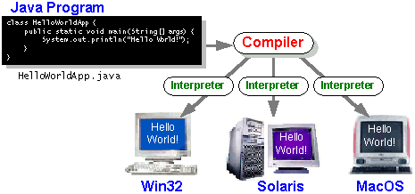

**Java platform**

A platform is the hardware or software environment in which a program runs.

The Java platform has two components:

* The Java Virtual Machine (Java VM)
* The Java Application Programming Interface (Java API)

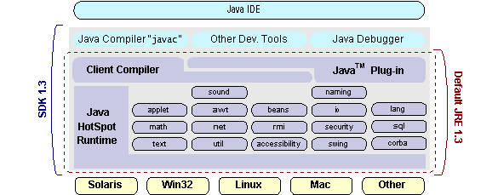

**CHAPTER-3**

**DESCRIPTION OF THE PROJECT**

**3.1PROBLEM DEFINITION:**

1. If the user has lost his security device, then their corresponding ciphertext in the cloud cannot be decrypted forever.
2. The data owners can have full authentication over their data

**3.2. PROPOSED SYSTEM**

* To overcome the existing problem we propose a new method. In this method the central authority has the full control.
* The central authority has play the role of encryption over the data on cloud.
* If the new user has registered on the cloud they need to get access from the central authority.
* After getting the access from the central authority they are allowed to transfer the fileover the cloude.

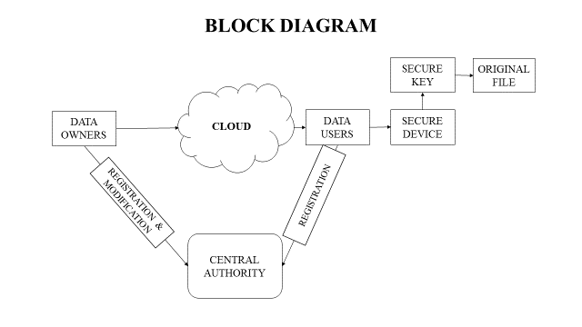

ADVANTAGES:

* The users can’t modify the data without getting access from the central authority.
* The data is transmitted in secure way.
* After updated to the new key, the data users can have access with the old key.

**CHAPTER 4**

**DESIGN OF THE SYSTEM**

**4.1 ARCHITECHTURAL DESIGN:**

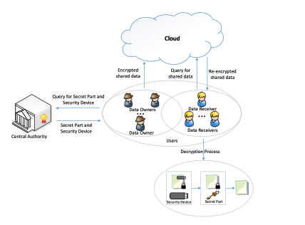

**Fig 4.1 Architectural Design**

**4.2UML DIAGRAMS**

UML stands for Unified Modeling Language. UML is a standardized general-purpose modeling language in the field of object-oriented software engineering. The standard is managed, and was created by, the Object Management Group.

**USE CASE DIAGRAM:**

The use case diagram in the Unified Modeling Language (UML) is a type of behavioral diagram defined by and created from a Use-case analysis. Its purpose is to present a graphical overview of the functionality provided by a system in terms of actors, their goals (represented as use cases), and any dependencies between those use cases.

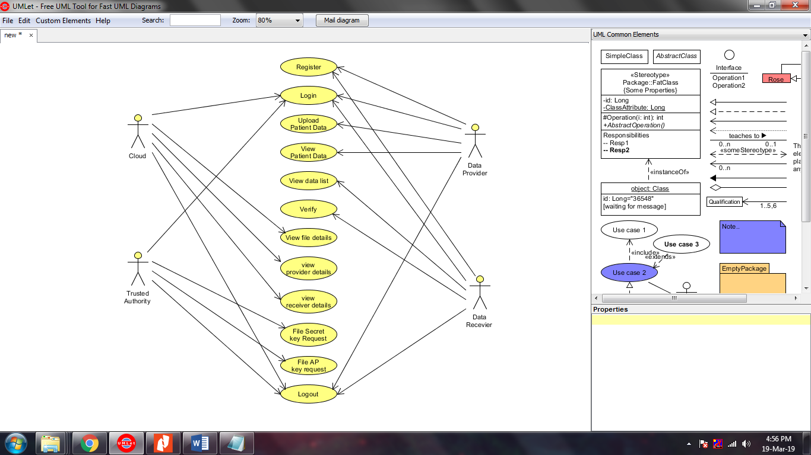

**Fig 4.2.1 Use case diagram**

**CLASS DIAGRAM:**

In software engineering, a class diagram in the Unified Modeling Language (UML) is a type of static structure diagram that describes the structure of a system by showing the system's classes, their attributes, operations (or methods), and the relationships among the classes.

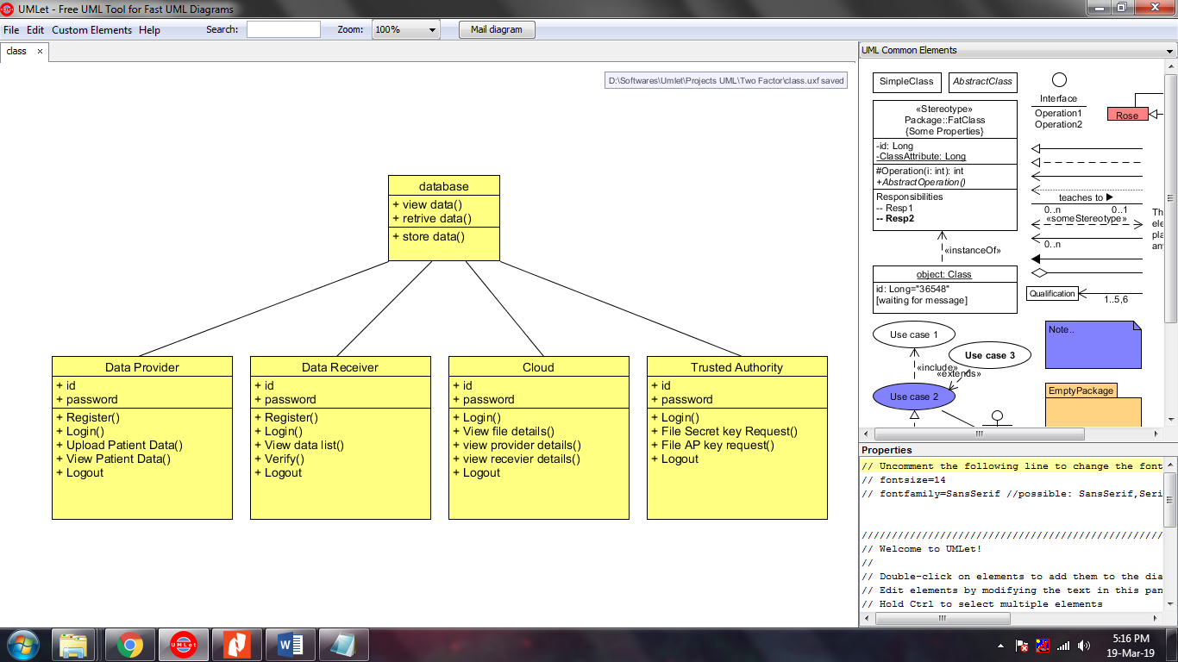

**Fig 4.2.2 Class Diagram**

**SEQUENCE DIAGRAM:**

The sequence diagram in Unified Modeling Language (UML) is a kind of interaction diagram that shows how processes operate with one another and in what order. It is a construct of a Message Sequence Chart. Sequence diagrams are sometimes called event diagrams, event scenarios, and timing diagrams.

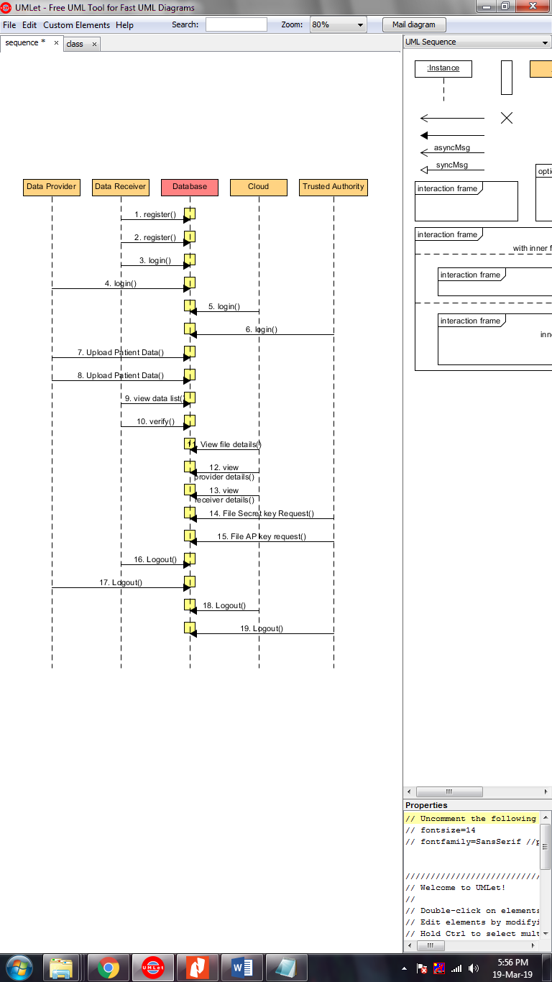

**Fig 4.2.3 Sequence Diagram**

**DEPLOYMENT:**

The Component diagrams are used to describe the components and deployment diagrams shows how they are deployed in hardware. UML is mainly designed to focus on the software artifacts of a system. However, these two diagrams are special diagrams used to focus on software and hardware components.

**Fig 4.2.4 Deployment diagram**

**DATA FLOW DIAGRAM:**

1. The DFD is also called as bubble chart. It is a simple graphical formalism that can be used to represent a system in terms of input data to the system, various processing carried out on this data, and the output data is generated by this system.
2. The data flow diagram (DFD) is one of the most important modeling tools. It is used to model the system components.

**DFD DIAGRAM**

**LEVEL 0:**

**LEVEL 1 :**

**LEVEL 2:**

**LEVEL 3:**

**CHAPTER 5**

**SYSTEM IMPLEMENTATION AND TESTING**

**5.1 MODULE**

* Registration
* Login / Logout
* File uploading
* Key management
* Data sharing
* Data viewing

**5.1.1. REGISTRATION**

* The registration module allow the user to create login username and the password by submitting their information like mail id, phone number, name, etc.
* By registering the network or cloud the user can gain access to the resources stored in the cloud.

**5.1.2. LOGIN / LOGOUT**

* In this module the user can login by using their unique username and password.
* The login module verify the user given username and password .
* If the username and password is matched the user can access the resources.
* If it does not match the user not allowed to access the resource.

**5.1.3. FILE UPLOADING**

* The files used to upload this module in the cloud server.
* User can select any file that they want to share.

**5.1.4. KEY MANAGEMENT**

* The central authority are responsible for file encryption.
* This module using double encrypt to uploaded file.
* The file can be encrypted using AES algorithm.

**5.1.5. DATA SHARING**

* This module is used to share the double encrypted file to the user.
* The file is directly shared to the particular user based on their id.

**5.1.6. DATA VIEWING**

* In this module the user can view the shared data.
* The user need to use the encrypted key to view the original file that the data owner shared.

**5.2HOMOMORPHICENCRYPTION (HE):**

Homomorphic encryption performs encryption on the encrypted data which is in the cloud. The homomorphic encryption schemes can be classified according to the operation that allows assessing on raw data, as the additive homomorphic encryption and multiplicative homomorphic encryption.

The major operation of the Homomorphic Encryption is as follows [14]:

1) **Key generation**: The client generates the public key (**pk**) and the secret key (**sk**).

2) **Encryption**: The client encrypts the data with encryption key. It sends the encrypted data and **pk** to the Cloud server.

3) **Storage**: The encrypted data and **pk** are stored in the cloud database.

4) **Request**: The client sends a request to the server to perform operations on encrypted data.

5) **Evaluation**: The processing server processes the request and performs the operations requested by the client.

6) **Response**: Cloud provider returns the processed result to the client.

7) **Decryption**: The client decrypts the returned result, using **sk**.

**5.3 TESTING**:

The purpose of testing is to discover errors. Testing is the process of trying to discover every conceivable fault or weakness in a work product. It provides a way to check the functionality of components, sub-assemblies, assemblies and/or a finished product It is the process of exercising software with the intent of ensuring that the Software system meets its requirements and user expectations and does not fail in an unacceptable manner.

**5.3.TYPES OF TESTS**

**Unit testing**

Unit testing involves the design of test cases that validate that the internal program logic is functioning properly, and that program inputs produce valid outputs. All decision branches and internal code flow should be validated.

**Integration testing**

Integration tests are designed to test integrated software components to determine if they actually run as one program. Integration tests demonstrate that although the components were individually satisfaction, as shown by successfully unit testing, the combination of components is correct and consistent.

**Functional test**

Functional tests provide systematic demonstrations that functions tested are available as specified by the business and technical requirements, system documentation, and user manuals.

Functional testing is centered on the following items:

Valid Input : identified classes of valid input must be accepted.

Invalid Input : identified classes of invalid input must be rejected.

Functions : identified functions must be exercised.

Output : identified classes of application outputs must be exercised.

Systems/Procedures: interfacing systems or procedures must be invoked.

Before functional testing is complete, additional tests are identified and the effective value of current tests is determined.

**System Test**

System testing ensures that the entire integrated software system meets requirements. It tests a configuration to ensure known and predictable results. An example of system testing is the configuration oriented system integration test. System testing is based on process descriptions and flows, emphasizing pre-driven process links and integration points.

**White Box Testing**

White Box Testing is a testing in which in which the software tester has knowledge of the inner workings, structure and language of the software, or at least its purpose. It is purpose. It is used to test areas that cannot be reached from a black box level.

**Black Box Testing**

Black Box Testing is testing the software without any knowledge of the inner workings, structure or language of the module being tested. It is a testing in which the software under test is treated, as a black box .you cannot “see” into it. The test provides inputs and responds to outputs without considering how the software works.

**Unit Testing:**

Unit testing is usually conducted as part of a combined code and unit test phase of the software lifecycle, although it is not uncommon for coding and unit testing to be conducted as two distinct phases.

**Test strategy and approach**

Field testing will be performed manually and functional tests will be written in detail.

**Test objectives**

* All field entries must work properly.
* Pages must be activated from the identified link.
* The entry screen, messages and responses must not be delayed.

**Features to be tested**

* Verify that the entries are of the correct format
* No duplicate entries should be allowed
* All links should take the user to the correct page.

# Integration Testing

Software integration testing is the incremental integration testing of two or more integrated software components on a single platform to produce failures caused by interface defects.

The task of the integration test is to check that components or software applications, e.g. components in a software system or – one step up – software applications at the company level – interact without error.

**Test Results:**

All the test cases mentioned above passed successfully. No defects encountered.

**CHAPTER 6**

**SCREENSHOTS**

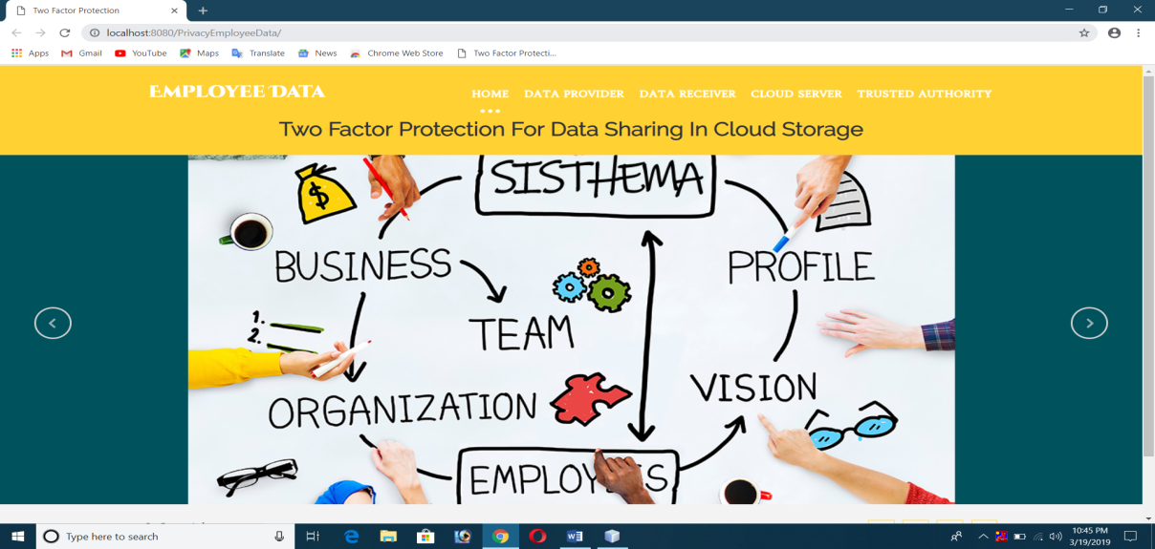

**Fig 6.1Home page**

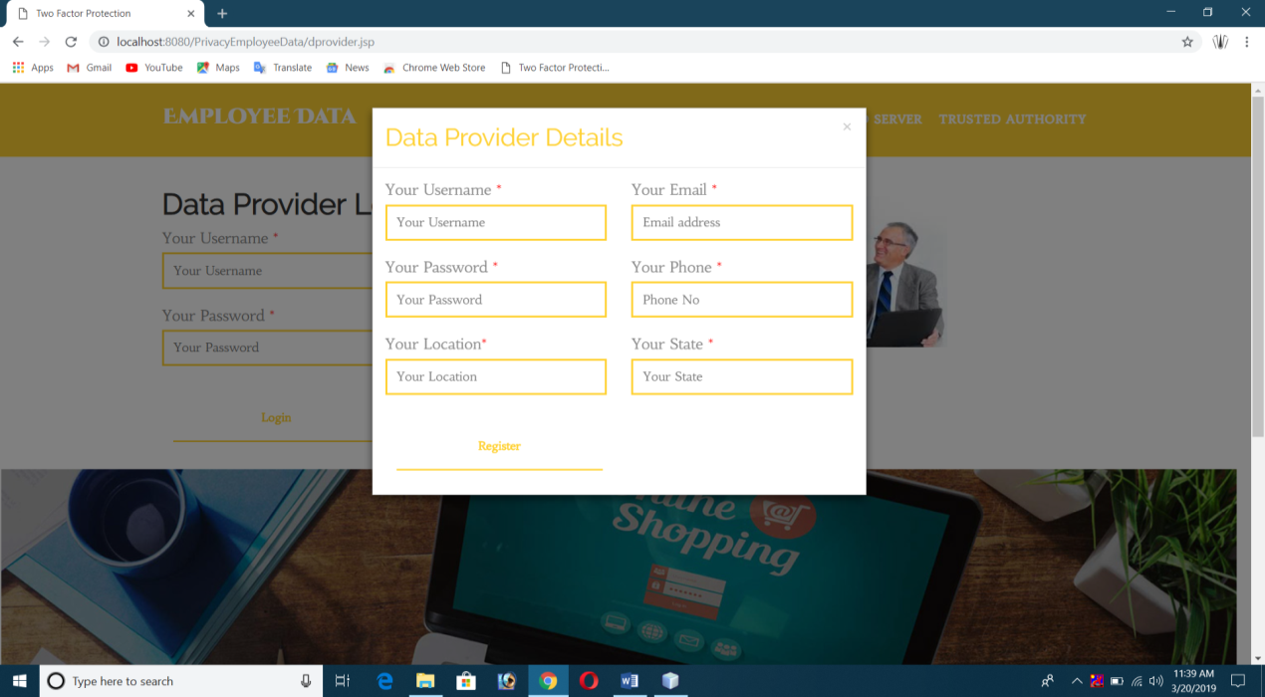

**Fig 6.2 Data provider registration**

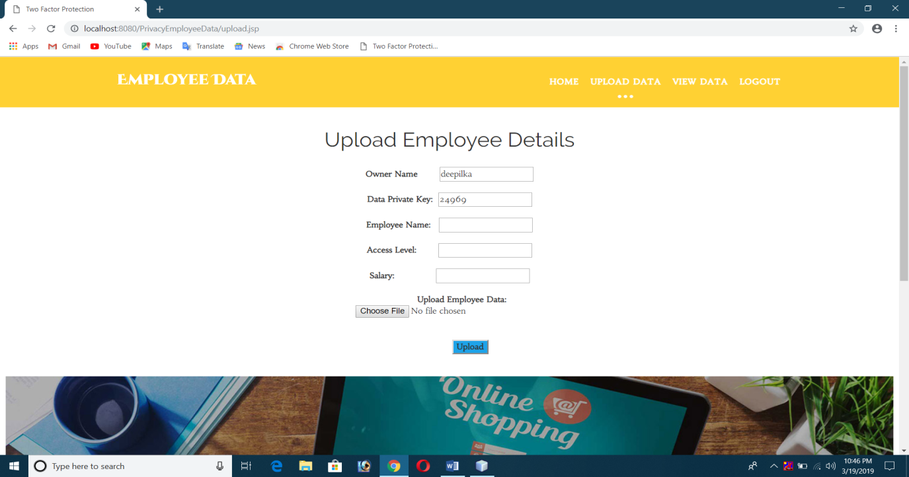

**Fig 6.3 Provider details**

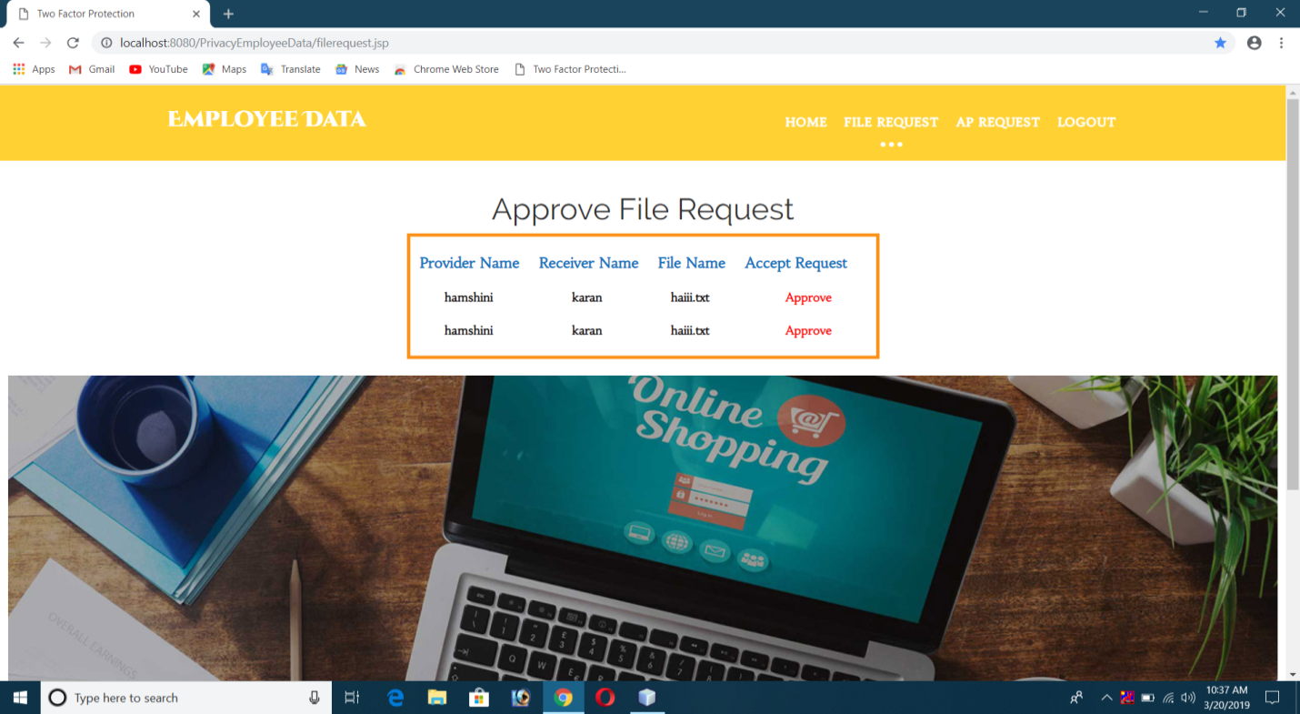

**Fig 6.5 Approval for file request**

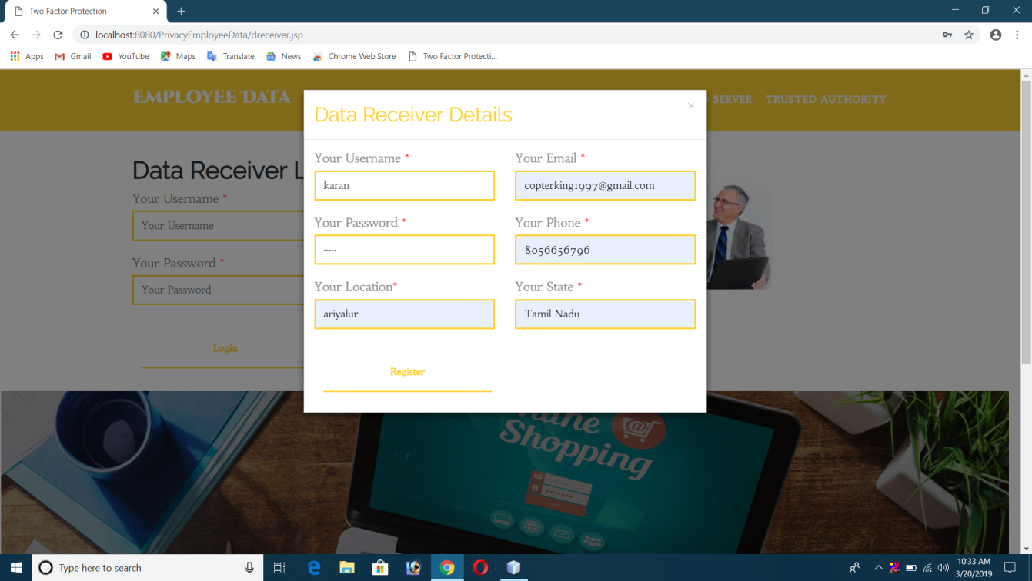

**Fig 6.6 Data receiver login**

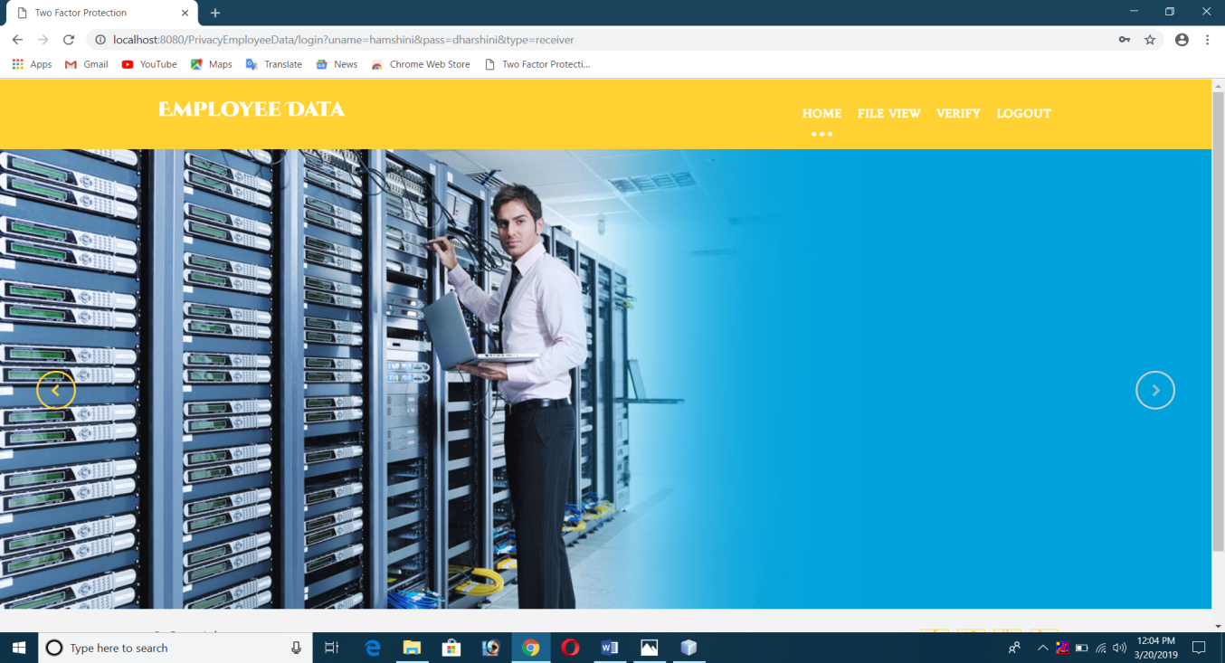

**Fig 6.7 Data receiver home page**

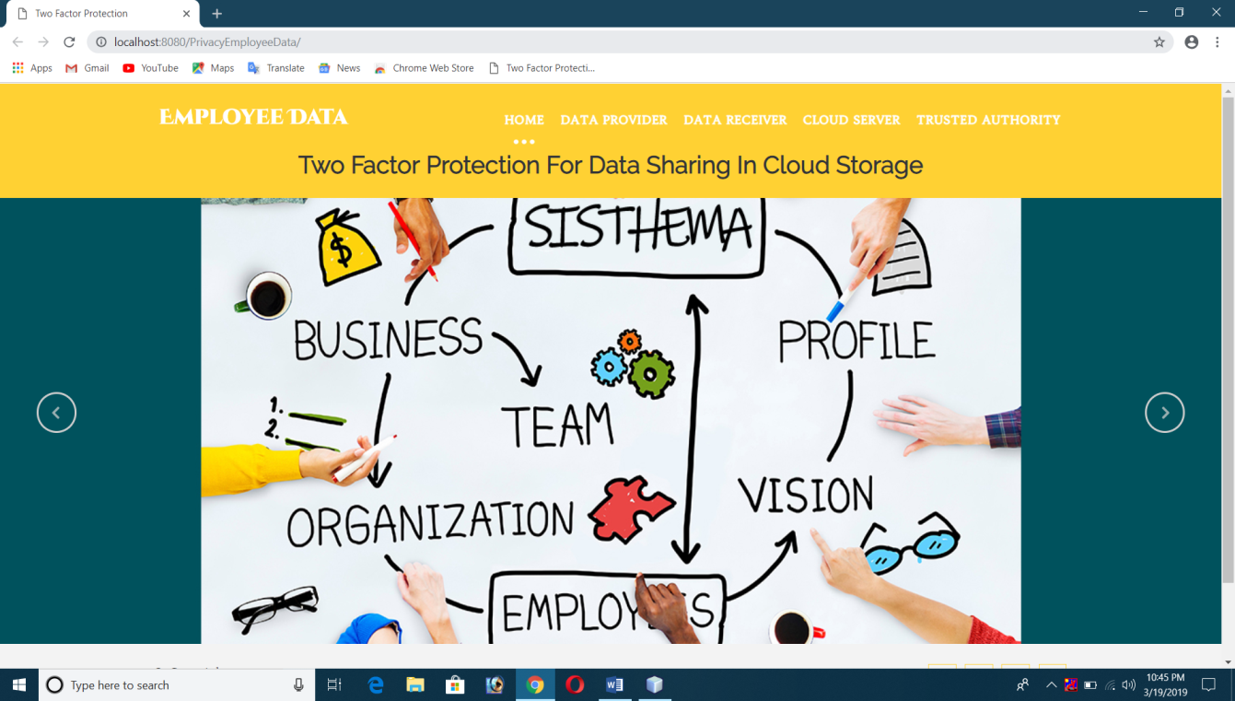

**Fig 6.9 Cloud homepage**

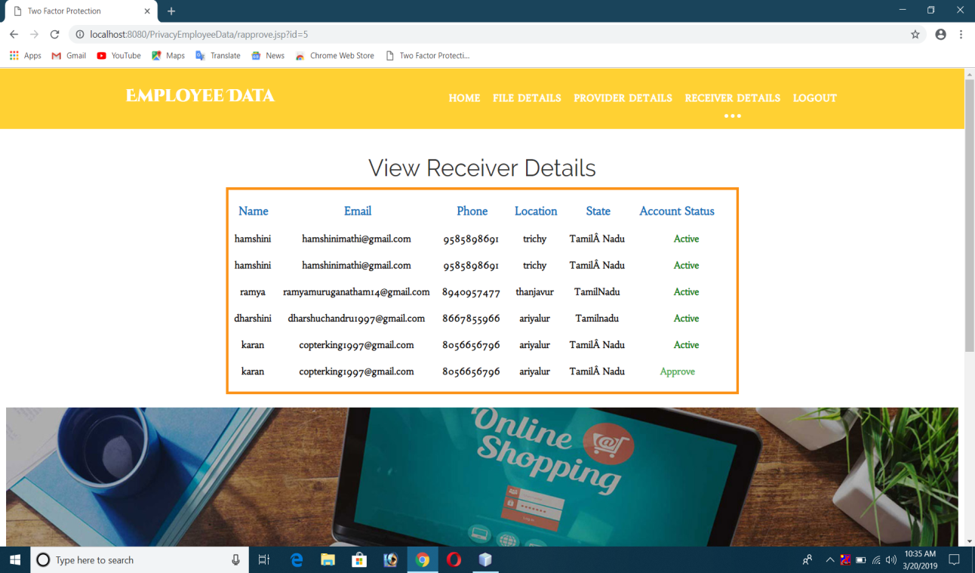

**Fig 6.10 Receiver details**

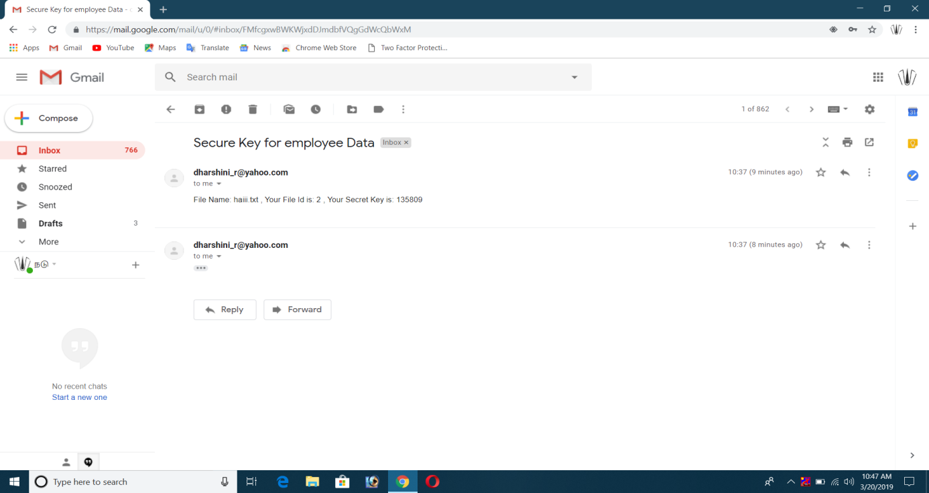

**Fig 6.11 Secret key**

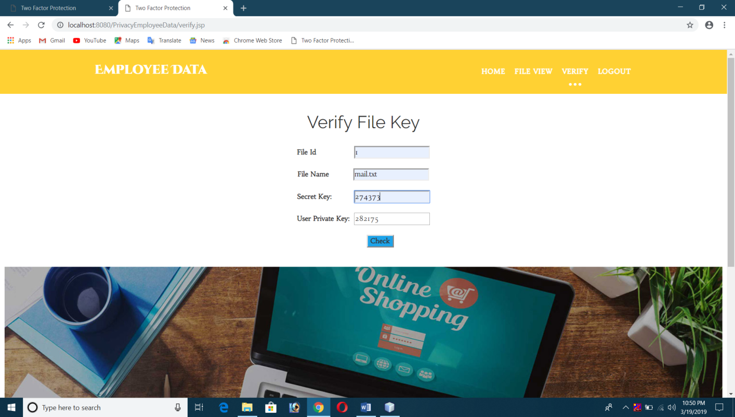

**Fig 6.12 Verifying Secret key**

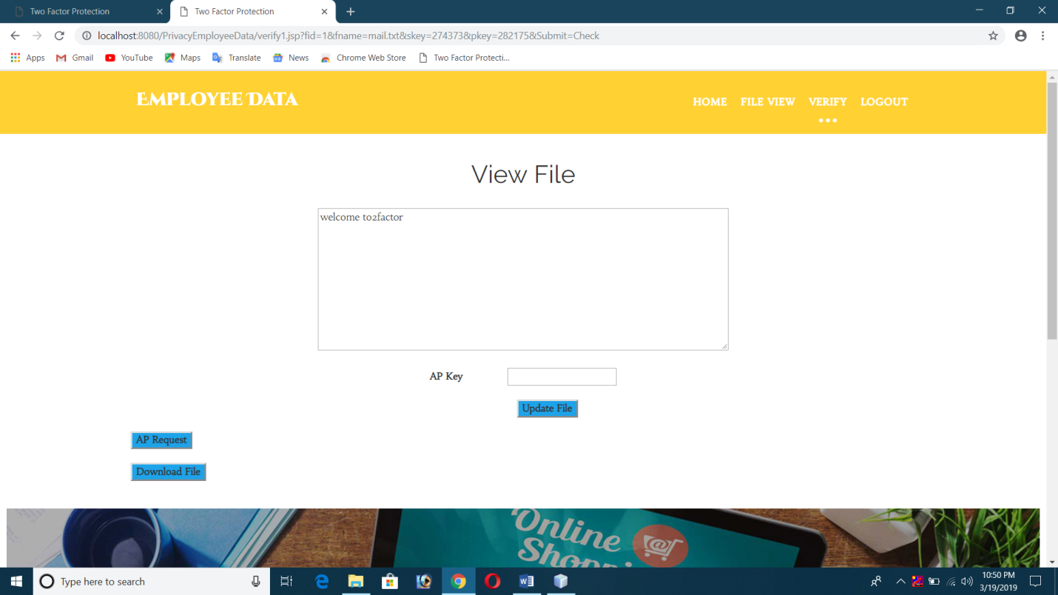

**Fig 6.13 Output CHAPTER 7**

**CONCLUSION**

The proposed system can extend a novel two-factor data security protection mechanism for cloud storage system, in which a data sender is allowed to encrypt the data with knowledge of the identity of a receiver only, while the receiver is required to use both his/her secret key and a security device to gain access to the data. Our solution not only enhances the confidentiality of the data, but also offers the revocability of the device so that once the device is revoked, the corresponding ciphertext will be updated automatically by the cloud server without any notice of the data owner. Furthermore, we presented the security proof and efficiency analysis for our system.

**APPENDIX**

**SOURCE CODE LISTING**

**LOGIN.JAVA**

/*

* To change this license header, choose License Headers in Project Properties.

* To change this template file, choose Tools | Templates

* and open the template in the editor.

*/

import static DbConnect.DB.Con;

importjava.io.IOException;

importjava.io.PrintWriter;

importjava.sql.Connection;

importjava.sql.PreparedStatement;

importjava.sql.ResultSet;

importjava.sql.SQLException;

importjava.util.logging.Level;

importjava.util.logging.Logger;

importjavax.servlet.RequestDispatcher;

importjavax.servlet.ServletException;

importjavax.servlet.http.HttpServlet;

importjavax.servlet.http.HttpServletRequest;

importjavax.servlet.http.HttpServletResponse;

importjavax.servlet.http.HttpSession;

/**

*

* @author Bhuvana-PC

*/

public class login extends HttpServlet {

/**

* Processes requests for both HTTP <code>GET</code> and <code>POST</code>

* methods.

*

* @param request servlet request

* @param response servlet response

* @throws ServletException if a servlet-specific error occurs

* @throws IOException if an I/O error occurs

*/

String uname,pass,type;

protected void processRequest(HttpServletRequest request, HttpServletResponse response)

throws ServletException, IOException {

response.setContentType("text/html;charset=UTF-8");

PrintWriter out = response.getWriter();

{

HttpSession session = request.getSession();

uname=request.getParameter("uname");

pass=request.getParameter("pass");

type=request.getParameter("type");

Connection con = Con();

if(type.equals("provider"))

{

try

{

PreparedStatement query=Con().prepareStatement("select * from preg where uname='"+uname+"' and pass='"+pass+"' and status='Active' ");

ResultSetrs = query.executeQuery();

if(rs.next())

{

session.setAttribute("uname", uname);

session.setAttribute("pkey", rs.getString("pkey"));

out.println("<script type=\"text/javascript\">");

out.println("alert(\"Welcome "+uname+"\")");

out.println("</script>");

RequestDispatcherrd=request.getRequestDispatcher("provider.jsp");

rd.include(request, response);

}

else

{

out.println("<script type=\"text/javascript\">");

out.println("alert(\"Please Check Your Account is activated or Not.\")");

out.println("</script>");

RequestDispatcherrd=request.getRequestDispatcher("dprovider.jsp");

rd.include(request, response);

}

} catch (SQLException ex)

{

System.out.println(ex);

}

finally

{

try {

con.close();

} catch (SQLException ex) {

Logger.getLogger(reg.class.getName()).log(Level.SEVERE, null, ex);

}

}

}

else if(type.equals("receiver"))

{

try

{

PreparedStatement query=Con().prepareStatement("select * from rreg where uname='"+uname+"' and pass='"+pass+"' and status='Active' ");

ResultSetrs = query.executeQuery();

if(rs.next())

{

session.setAttribute("uname", uname);

session.setAttribute("pkey", rs.getString("pkey"));

out.println("<script type=\"text/javascript\">");

out.println("alert(\"Welcome "+uname+"\")");

out.println("</script>");

RequestDispatcherrd=request.getRequestDispatcher("receiver.jsp");

rd.include(request, response);

}

else

{

out.println("<script type=\"text/javascript\">");

out.println("alert(\"Please Check Your Account is activated or Not.\")");

out.println("</script>");

RequestDispatcherrd=request.getRequestDispatcher("dreceiver.jsp");

rd.include(request, response);

}

} catch (SQLException ex)

{

System.out.println(ex);

}

finally

{

try {

con.close();

} catch (SQLException ex) {

Logger.getLogger(reg.class.getName()).log(Level.SEVERE, null, ex);

}

}

}

else if(type.equals("cloud")&&uname.equals("cloud")&&pass.equals("cloud"))

{

out.println("<script type=\"text/javascript\">");

out.println("alert(\"Welcome cloud\")");

out.println("</script>");

RequestDispatcherrd=request.getRequestDispatcher("cloud.jsp");

rd.include(request, response);

}

else if(type.equals("ta")&&uname.equals("ta")&&pass.equals("ta"))

{

out.println("<script type=\"text/javascript\">");

out.println("alert(\"Welcome Trusted Authority\")");

out.println("</script>");

RequestDispatcherrd=request.getRequestDispatcher("ta.jsp");

rd.include(request, response);

}

else

{

out.println("<script type=\"text/javascript\">");

out.println("alert(\"Invalid Credentials\")");

out.println("</script>");

RequestDispatcherrd=request.getRequestDispatcher("index.jsp");

rd.include(request, response);

}

}

}

// <editor-fold defaultstate="collapsed" desc="HttpServlet methods. Click on the + sign on the left to edit the code.">

/**

* Handles the HTTP <code>GET</code> method.

*

* @param request servlet request

* @param response servlet response

* @throws ServletException if a servlet-specific error occurs

* @throws IOException if an I/O error occurs

*/

@Override

protected void doGet(HttpServletRequest request, HttpServletResponse response)

throws ServletException, IOException {

processRequest(request, response);

}

/**

* Handles the HTTP <code>POST</code> method.

*

* @param request servlet request

* @param response servlet response

* @throws ServletException if a servlet-specific error occurs

* @throws IOException if an I/O error occurs

*/

@Override

protected void doPost(HttpServletRequest request, HttpServletResponse response)

throws ServletException, IOException {

processRequest(request, response);

}

/**

* Returns a short description of the servlet.

*

* @return a String containing servlet description

*/

@Override

public String getServletInfo() {

return "Short description";

}// </editor-fold>

}

**REG.JAVA**

/*

* To change this license header, choose License Headers in Project Properties.

* To change this template file, choose Tools | Templates

* and open the template in the editor.

*/

import static DbConnect.DB.Con;

importjava.io.IOException;

importjava.io.PrintWriter;

importjava.sql.Connection;

importjava.sql.PreparedStatement;

importjava.sql.ResultSet;

importjava.sql.SQLException;

importjava.util.logging.Level;

importjava.util.logging.Logger;

importjavax.servlet.RequestDispatcher;

importjavax.servlet.ServletException;

importjavax.servlet.http.HttpServlet;

importjavax.servlet.http.HttpServletRequest;

importjavax.servlet.http.HttpServletResponse;

importjavax.servlet.http.HttpSession;

/**

*

* @author Bhuvana-PC

*/

public class login extends HttpServlet {

/**

* Processes requests for both HTTP <code>GET</code> and <code>POST</code>

* methods.

*

* @param request servlet request

* @param response servlet response

* @throws ServletException if a servlet-specific error occurs

* @throws IOException if an I/O error occurs

*/

String uname,pass,type;

protected void processRequest(HttpServletRequest request, HttpServletResponse response)

throws ServletException, IOException {

response.setContentType("text/html;charset=UTF-8");

PrintWriter out = response.getWriter();

{

HttpSession session = request.getSession();

uname=request.getParameter("uname");

pass=request.getParameter("pass");

type=request.getParameter("type");

Connection con = Con();

if(type.equals("provider"))

{

try

{

PreparedStatement query=Con().prepareStatement("select * from preg where uname='"+uname+"' and pass='"+pass+"' and status='Active' ");

ResultSetrs = query.executeQuery();

if(rs.next())

{

session.setAttribute("uname", uname);

session.setAttribute("pkey", rs.getString("pkey"));

out.println("<script type=\"text/javascript\">");

out.println("alert(\"Welcome "+uname+"\")");

out.println("</script>");

RequestDispatcherrd=request.getRequestDispatcher("provider.jsp");

rd.include(request, response);

}

else

{

out.println("<script type=\"text/javascript\">");

out.println("alert(\"Please Check Your Account is activated or Not.\")");

out.println("</script>");

RequestDispatcherrd=request.getRequestDispatcher("dprovider.jsp");

rd.include(request, response);

}

} catch (SQLException ex)

{

System.out.println(ex);

}

finally

{

try {

con.close();

} catch (SQLException ex) {

Logger.getLogger(reg.class.getName()).log(Level.SEVERE, null, ex);

}

}

}

else if(type.equals("receiver"))

{

try

{

PreparedStatement query=Con().prepareStatement("select * from rreg where uname='"+uname+"' and pass='"+pass+"' and status='Active' ");

ResultSetrs = query.executeQuery();

if(rs.next())

{

session.setAttribute("uname", uname);

session.setAttribute("pkey", rs.getString("pkey"));

out.println("<script type=\"text/javascript\">");

out.println("alert(\"Welcome "+uname+"\")");

out.println("</script>");

RequestDispatcherrd=request.getRequestDispatcher("receiver.jsp");

rd.include(request, response);

}

else

{

out.println("<script type=\"text/javascript\">");

out.println("alert(\"Please Check Your Account is activated or Not.\")");

out.println("</script>");

RequestDispatcherrd=request.getRequestDispatcher("dreceiver.jsp");

rd.include(request, response);

}

} catch (SQLException ex)

{

System.out.println(ex);

}

finally

{

try {

con.close();

} catch (SQLException ex) {

Logger.getLogger(reg.class.getName()).log(Level.SEVERE, null, ex);

}

}

}

else if(type.equals("cloud")&&uname.equals("cloud")&&pass.equals("cloud"))

{

out.println("<script type=\"text/javascript\">");

out.println("alert(\"Welcome cloud\")");

out.println("</script>");

RequestDispatcherrd=request.getRequestDispatcher("cloud.jsp");

rd.include(request, response);

}

else if(type.equals("ta")&&uname.equals("ta")&&pass.equals("ta"))

{

out.println("<script type=\"text/javascript\">");

out.println("alert(\"Welcome Trusted Authority\")");

out.println("</script>");

RequestDispatcherrd=request.getRequestDispatcher("ta.jsp");

rd.include(request, response);

}

else

{

out.println("<script type=\"text/javascript\">");

out.println("alert(\"Invalid Credentials\")");

out.println("</script>");

RequestDispatcherrd=request.getRequestDispatcher("index.jsp");

rd.include(request, response);

}

}

}

// <editor-fold defaultstate="collapsed" desc="HttpServlet methods. Click on the + sign on the left to edit the code.">

/**

* Handles the HTTP <code>GET</code> method.

*

* @param request servlet request

* @param response servlet response

* @throws ServletException if a servlet-specific error occurs

* @throws IOException if an I/O error occurs

*/

@Override

protected void doGet(HttpServletRequest request, HttpServletResponse response)

throws ServletException, IOException {

processRequest(request, response);

}

/**

* Handles the HTTP <code>POST</code> method.

*

* @param request servlet request

* @param response servlet response

* @throws ServletException if a servlet-specific error occurs

* @throws IOException if an I/O error occurs

*/

@Override

protected void doPost(HttpServletRequest request, HttpServletResponse response)

throws ServletException, IOException {

processRequest(request, response);

}

/**

* Returns a short description of the servlet.

*

* @return a String containing servlet description

*/

@Override

public String getServletInfo() {

return "Short description";

}// </editor-fold>

}

**REFERENCES:**

[1] C. Wang, S. S. Chow, Q. Wang, K. Ren, and W. Lou, “Privacy-preserving public auditing for secure cloud storage,” Computers, IEEE Transactionson, vol. 62, no. 2, pp. 362–375, 2013.

[2] C. Wang, Q. Wang, K. Ren, N. Cao, and W. Lou, “Toward secure and dependable storage services in cloud computing,” Services Computing,IEEE Transactions on, vol. 5, no. 2, pp. 220–232, 2012.

[3] Y. Zhu, G.-J. Ahn, H. Hu, S. S. Yau, H. G. An, and C.-J. Hu, “Dynamic audit services for outsourced storages in clouds,” Services Computing,IEEE Transactions on, vol. 6, no. 2, pp. 227–238, 2013.

[4] H. C. Chen, Y. Hu, P. P. Lee, and Y. Tang, “Nccloud: a networkcoding-basedstorage system in a cloud-of-clouds,” Computers, IEEETransactions on, vol. 63, no. 1, pp. 31–44, 2014.

[5] Y. Dodis, J. Katz, S. Xu, and M. Yung, “Key-insulated public key cryptosystems,”in Advances in Cryptology–EUROCRYPT 2002. Springer,2002, pp. 65–82.

[6] G. Hanaoka, Y. Hanaoka, and H. Imai, “Parallel key-insulated public keyencryption,” in Public Key Cryptography-PKC 2006. Springer, 2006,pp. 105–122.

[7] B. Libert, J.-J. Quisquater, and M. Yung, “Parallel key-insulated publickey encryption without random oracles,” in Public Key Cryptography–PKC 2007. Springer, 2007, pp. 298–314.

[8] J. Liu, K. Liang, W. Susilo, J. Liu, and Y. Xiang, “Two-factor datasecurity protection mechanism for cloud storage system,” Computers,IEEE Transactions on, vol. 65, no. 6, pp. 1992–2004, 2016.

[9] J. K. Liu and D. S. Wong, “Solutions to key exposure problem in ringsignature.” IJ Network Security, vol. 6, no. 2, pp. 170–180, 2008.

[10] A. Sahai and B. Waters, “Fuzzy identity-based encryption,” in Advancesin Cryptology–EUROCRYPT 2005. Springer, 2005, pp. 457–473.